#### Want to host an event?

#### Contact May or Tyler about renting the Slow Bell for your special event!

# Chebeague Island, Maine

**(207) 846-3078  
Hours STARTNG June 10th!**

**Thurs, Fri, Sat, Sun**

**Take-out and dinner 5-9 p.m.**

**Bar 5 p.m. -midnight**

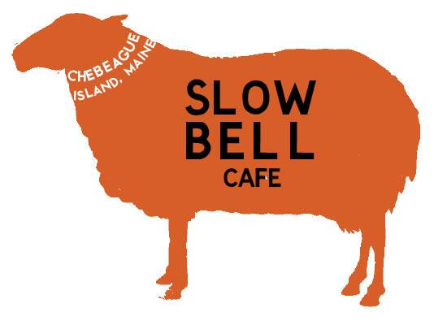

**SLOW BELL CAFE**

Our mission is to provide the island community with an enjoyable meal, a place to visit with friends, and a comfortable experience for everyone. We welcome your suggestions!

Burgers

Served on a bulkie roll. Add bacon, cheese or mushrooms $1.50 each

Slow Bell Burger $8

6 ounce burger with lettuce, tomato, onions and pickles.

BBQ Burger $9

6 ounce burger with grilled onions and BBQ sauce.

Blue Mango Veggie $8

6 ounce Maine-made patty with lettuce, tomato, onions, pickles.

Seafood

Popcorn Shrimp $14

with French Fries and Cole Slaw

Fried Haddock $14

with French Fries and Cole Slaw

Fried Haddock Sandwich $11

with lettuce, tomato and mayo

Haddock Taco $12

with red cabbage, pickled onions, and lime crema

Bombs $8

Grilled shaved steak or chicken served on a sub roll with peppers, onions, mushrooms and cheese.

Pizzas

Hand-tossed dough with red or pesto sauce

Small (10-inch) $9

Large (14-inch) $12

Toppings

($1 each for small, $2 each for large)

Peppers, onions, mushrooms, black olives, spinach, tomatoes, pepperoni, burger, chicken, bacon, feta cheese, extra cheese.

Please give us at least 30 minutes on takeout orders. We appreciate your patience with large orders.

**Starters**

**Chicken Wings** $1 each

(6 wing minimum)

BBQ, Buffalo, or Original

**Slow Bell Nachos** $8

With peppers, onions, olives, ground beef, and cheese

**Chicken Fingers**

Small (3) $5 or Large (6) $8

**French Fries**

Small $4 Large $7

**Salads**

Small $5 or Large $8

Add chicken $4 or bacon $1.50

**Garden Salad:** Lettuce with fresh seasonal vegetables.

**Caesar:** Romaine with creamy dressing, parmesan cheese, and garlic croutons.

**Greek:** Lettuce, spinach, tomatoes, olives, feta cheese.